 | Kaufman County District Attorney’s Office  and Kaufman County Sheriff’s Office | 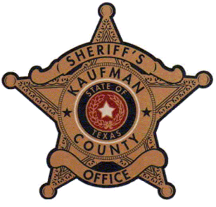

2022 Citizens Academy
Protecting our most vulnerable citizens
Striving for justice for all victims of crime
Making Kaufman County a safer place to live

If you are interested in learning more about the Kaufman County law enforcement and the judicial process, the Citizens Academy is for you!

15-week course March 22 – June 28, 2021
Tuesdays 6pm – 8pm

Contacts:
DA Chief Investigator Mike Holley – 469-376-4791
KSO LT. Rick Moosbrugger – 972-932-9778
ksotraining@kaufmanso.com

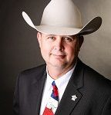

Kaufman County District Attorney  Erleigh N. Wiley |  | Kaufman County Sheriff  Bryan Beavers

